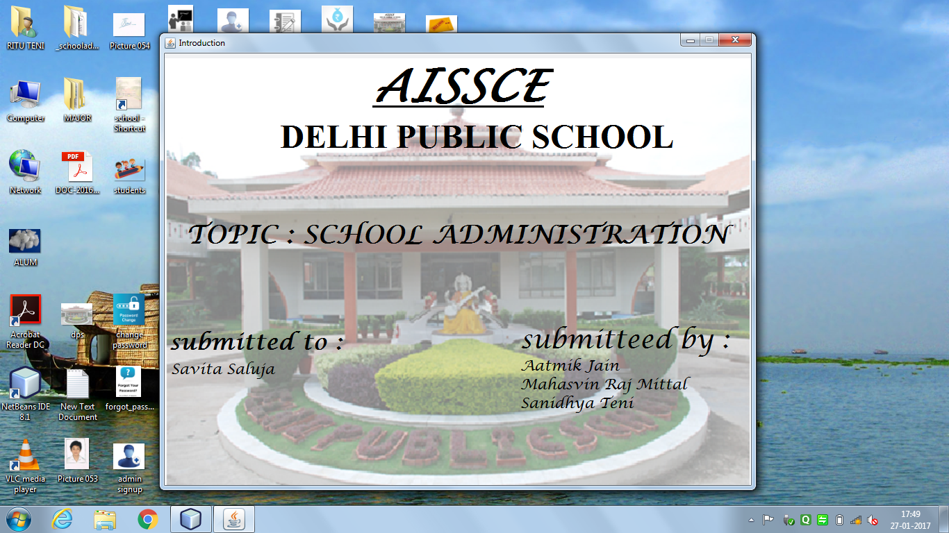

new AdminLogin().setVisible(true);

this.dispose();

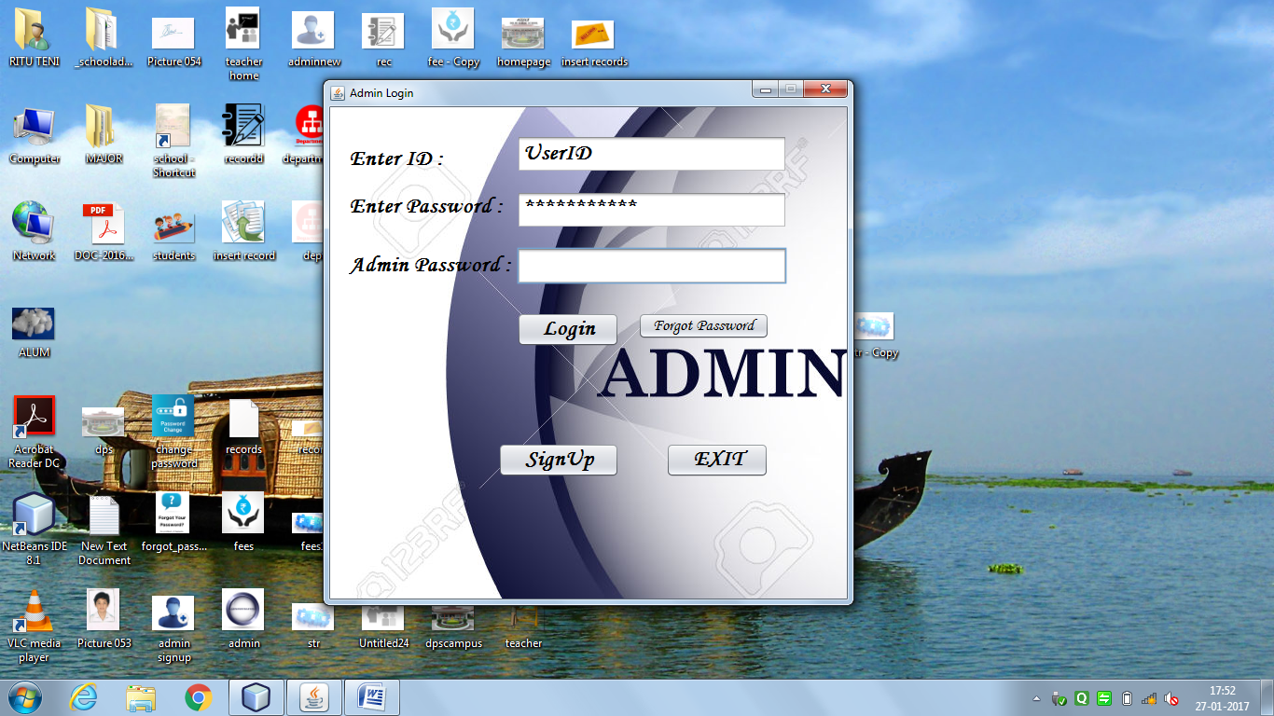

import java.sql.*;

import javax.swing.JOptionPane;

Code for Login Button:

String id = StrID.getText(); //CAPS are not cared

String pass = StrPass.getText();

String adpass = StrAdp.getText();

If (adpass.equals("1234"))

{

try{

Class.forName("com.mysql.jdbc.Driver");

Connection con = DriverManager.getConnection("jdbc:mysql://localhost:3306/schooladmin",

"root",

"mysql");

Statement stmt = con.createStatement();

String query = "Select * from adminlogin where ID = '" +id+ "' and Password = '" +pass+ "'";

ResultSet rs = stmt.executeQuery(query);

if(rs.next())

{

new AdminHomePage().setVisible(true);

this.dispose();

}

else

JOptionPane.showMessageDialog(this, "Incorrect ID/Password","ERROR",JOptionPane.ERROR_MESSAGE);

StrID.setText("");

StrPass.setText("");

}catch(ClassNotFoundException | SQLException e){JOptionPane.showMessageDialog(this,e,"ERROR",JOptionPane.ERROR_MESSAGE);}

}

else

{

JOptionPane.showMessageDialog(this, "Incorrect Admin Password","ERROR",JOptionPane.ERROR_MESSAGE);

}

StrID.setText("");

StrPass.setText("");

StrAdp.setText("");

}

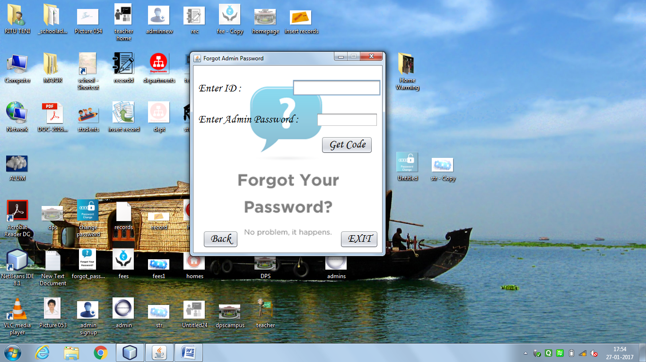

import java.sql.*;

import javax.swing.JOptionPane;

Code for Get Code Button:

String id = txtid.getText();

String adpass = txtAdp.getText();

if(adpass.equals("1234"))

{try{

Class.forName("com.mysql.jdbc.Driver");

Connection con = DriverManager.getConnection("jdbc:mysql://localhost:3306/schooladmin",

"root",

"mysql");

Statement stmt = con.createStatement();

String query = "Select ID from adminlogin where ID = '" + id + "'";

ResultSet rs = stmt.executeQuery(query);

if (rs.next())

{

JOptionPane.showMessageDialog(this, Gcode + "\n" + "Please Enter This Code");

jLabel2.setVisible(true);

txtcode.setVisible(true);

jButton2.setVisible(true);

}

else

{

JOptionPane.showMessageDialog(this, "Incorrect ID","ERROR",JOptionPane.ERROR_MESSAGE);

txtid.setText("");

txtAdp.setText("");

}

}catch(ClassNotFoundException | SQLException e){JOptionPane.showMessageDialog(this, e);}

jButton2.enable(true);

}

else

{

JOptionPane.showMessageDialog(this, "Incorrect Admin Password");

txtid.setText("");

txtAdp.setText("");

}

}

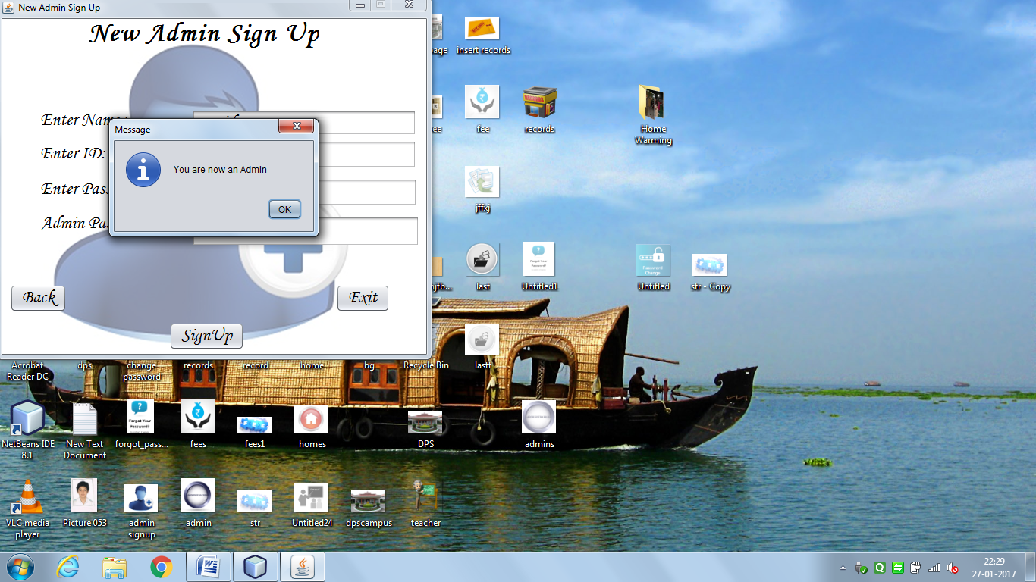

import java.sql.*;

import javax.swing.JOptionPane;

Code for Sign Up Button:

String nm = name.getText();

String id = ID.getText();

String pass = Password.getText();

String adpass = StrAdp.getText();

if(adpass.equals("1234"))

{

try{

Class.forName("com.mysql.jdbc.Driver");

Connection con = DriverManager.getConnection("jdbc:mysql://localhost:3306/schooladmin",

"root",

"mysql");

Statement stmt = con.createStatement();

String query = "insert into AdminLogin values('" +id+ "','" +pass+ "','" +nm+ "')";

if (nm.matches("")||id.matches("")||pass.matches(""))

{

JOptionPane.showMessageDialog(this, "Please fill all the Entries","ERROR",JOptionPane.ERROR_MESSAGE);

}

else

{ stmt.executeUpdate(query);

JOptionPane.showMessageDialog(this,"You are now an Admin");

new AdminHomePage().setVisible(true);

this.dispose();

}

}catch(ClassNotFoundException | SQLException e){JOptionPane.showMessageDialog(this, "ID already Exists","ERROR",JOptionPane.ERROR_MESSAGE);}

}

else

JOptionPane.showMessageDialog(this, "Incorrect Admin Password","ERROR",JOptionPane.ERROR_MESSAGE);

name.setText("");

ID.setText("");

Password.setText("");

StrAdp.setText("");

}

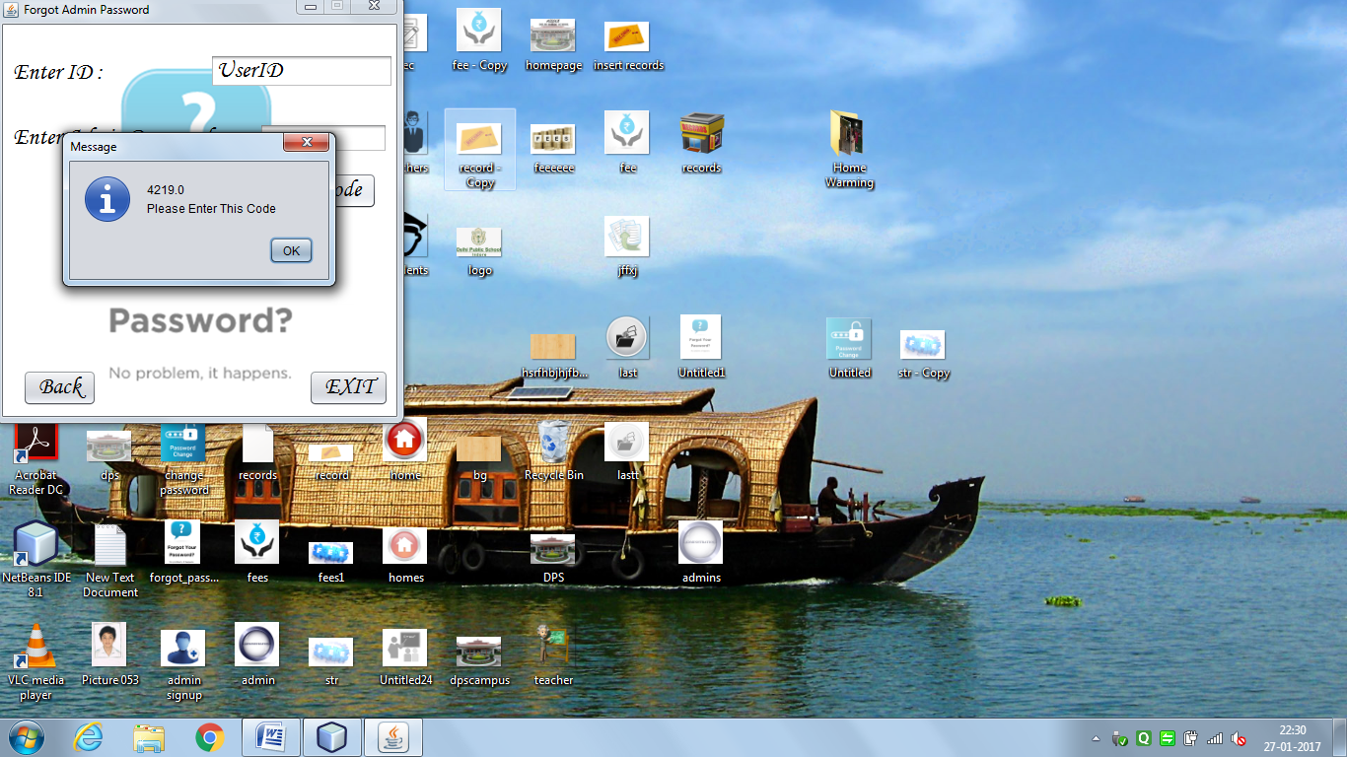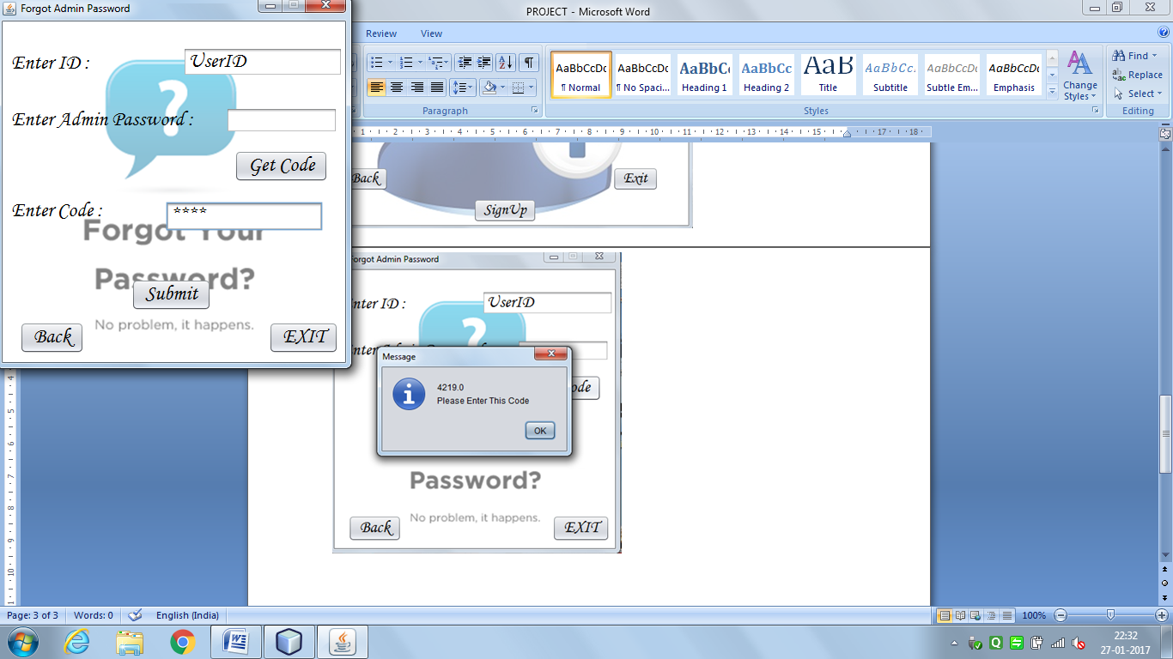

try{

double code = Double.parseDouble(txtcode.getText());

if (code==Gcode)

{

new ChangeAdminPass().setVisible(true);

this.dispose();

}

else

{

JOptionPane.showMessageDialog(this,"Enter correct Code");

txtcode.setText("");

}

}catch(NumberFormatException e){JOptionPane.showMessageDialog(this,"Enter correct Code","ERROR",JOptionPane.ERROR_MESSAGE );}

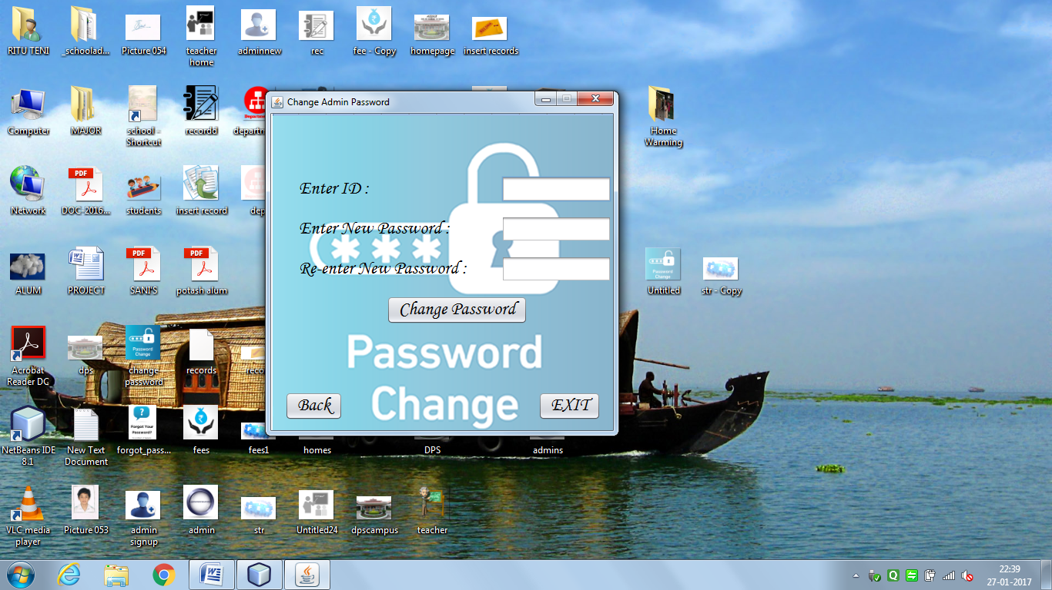

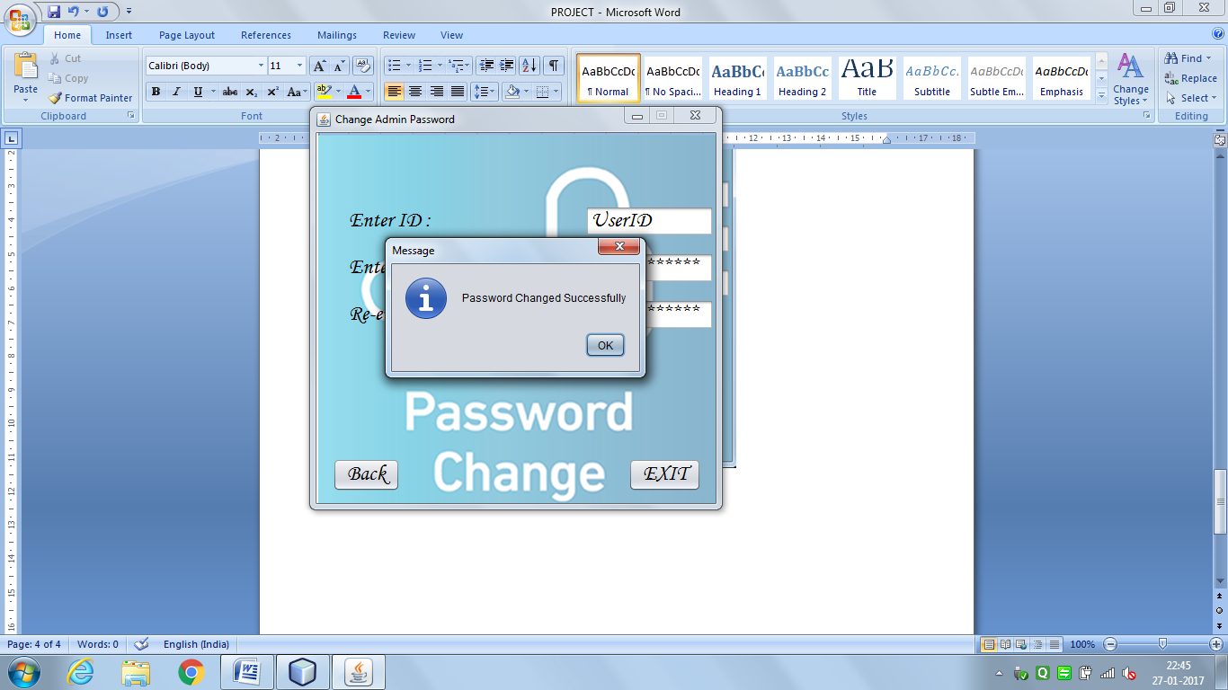

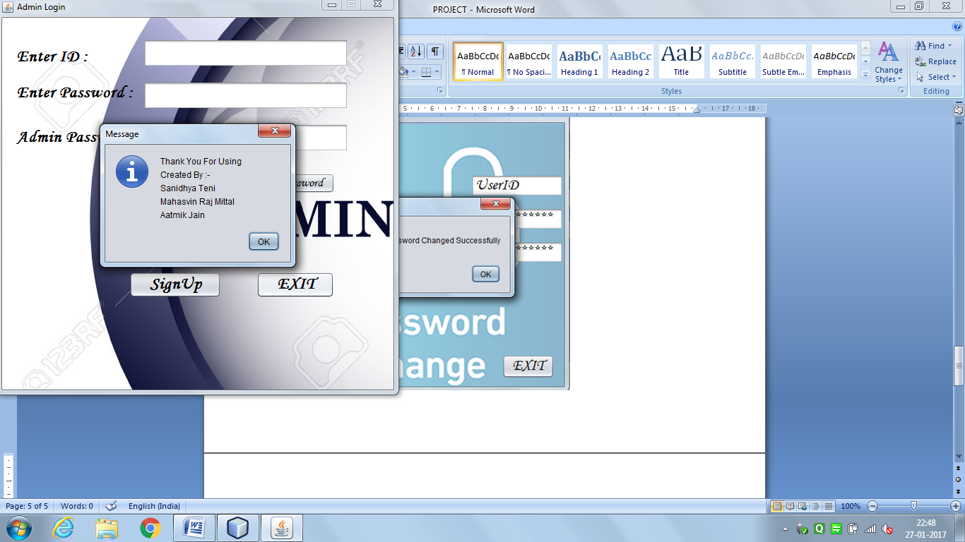

Exit Button:

JOptionPane.showMessageDialog(this,"Thank You For Using" + "\n"

+ "Created By :-" + "\n"

+ "Sanidhya Teni" + "\n"

+ "Mahasvin Raj Mittal" + "\n"

+ "Aatmik Jain");

System.exit(0);

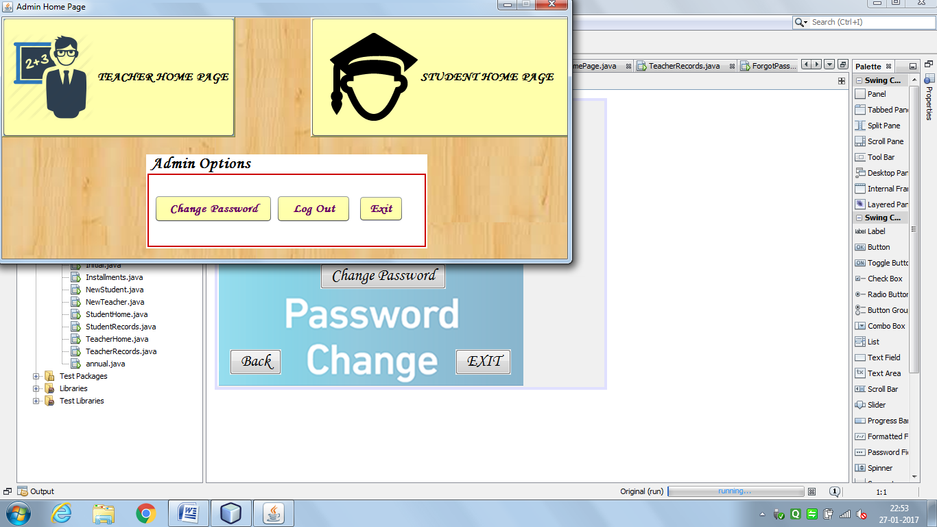

Teacher Home Page Button:

new TeacherHome().setVisible(true);

this.dispose();

Student Home Page button:

new StudentHome().setVisible(true);

this.dispose();

Change Password Button:

new ChangeAdminPass2().setVisible(true);

this.dispose();

LogOut Button:

new AdminLogin().setVisible(true);

this.dispose();

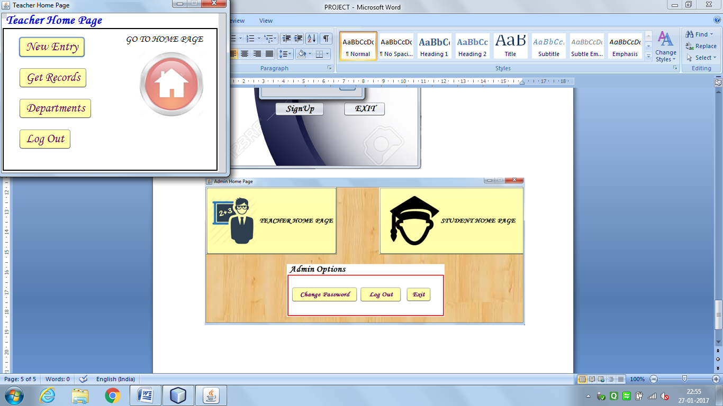

New Entry Button:

new NewTeacher().setVisible(true);

this.dispose();

Get Records Button:

new TeacherRecords().setVisible(true);

this.dispose();

Departments Button:

new Dept().setVisible(true);

this.dispose();

Back To Home Page Button:

new AdminHomePage().setVisible(true);

this.dispose();

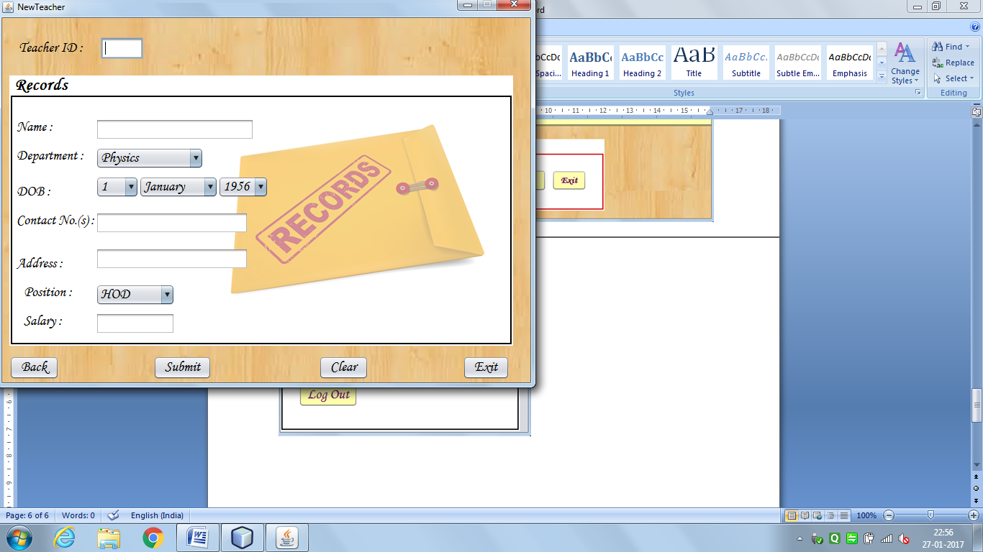

import java.sql.*;

import javax.swing.JOptionPane;

public NewTeacher() {

initComponents();

}

String tid,nm,cno,add,post,dob,dept,month,sal;

int dd,mm,yy;

Submit Button:

tid = Tid.getText();

if(tid.isEmpty())

{

JOptionPane.showMessageDialog(this,"Please enter the Teacher ID","Error",JOptionPane.ERROR_MESSAGE);

}

else

{

nm = Name.getText();

dept = (String)jComboBox1.getSelectedItem();

dd = Integer.parseInt((String)jComboBox3.getSelectedItem());

month = (String)jComboBox4.getSelectedItem();

switch (month)

{

case "January" : mm = 1;

break;

case "February" : mm = 2;

break;

case "March" : mm = 3;

break;

case "April" : mm = 4;

break;

case "May" : mm = 5;

break;

case "June" : mm = 6;

Break;

case "July" : mm = 7;

break;

case "August" : mm = 8;

break;

case "September": mm = 9;

break;

case "October" : mm = 10;

break;

case "November" : mm = 11;

break;

case "December" : mm = 12;

break;

}

yy = Integer.parseInt((String) jComboBox5.getSelectedItem());

dob = yy+"/"+mm+"/"+dd ;

cno = Cno.getText();

add = Add.getText();

post = (String)jComboBox6.getSelectedItem();

sal = Sal.getText();

try{

Class.forName("com.mysql.jdbc.Driver");

Connection con = DriverManager.getConnection("jdbc:mysql://localhost:3306/schooladmin",

"root",

"mysql");

Statement stmt = con.createStatement();

String check = "Select * from Teacher1 where Tid = '" +tid+"'";

ResultSet rs = stmt.executeQuery(check);

if(rs.next())

{

JOptionPane.showMessageDialog(this,"Teacher ID already exists" +"\n" +"Please Enter another Teacher ID","Error",JOptionPane.ERROR_MESSAGE);

Tid.setText("");

}

else

{

If (nm.isEmpty()||cno.isEmpty()||add.isEmpty()||sal.isEmpty())

{

JOptionPane.showMessageDialog(this,"Please fill all the entries","Error",JOptionPane.ERROR_MESSAGE);

}

else

{

z String query = "insert into teacher1 values('" +tid+ "','" +nm+ "','" +dept+ "','" +dob+ "','" +cno+ "','" +add+ "','" +post+ "','" +sal+"')";

stmt.executeUpdate(query);

JOptionPane.showMessageDialog(this, "Successfully Entered");

}

}

}catch(ClassNotFoundException | SQLException e){JOptionPane.showMessageDialog(this, e);}

}

Clear Button:

Tid.setText("");

Name.setText("");

Cno.setText("");

Add.setText("");

Sal.setText("");

jComboBox1.setSelectedIndex(0);

jComboBox3.setSelectedIndex(0);

jComboBox4.setSelectedIndex(0);

jComboBox5.setSelectedIndex(0);

jComboBox6.setSelectedIndex(0);

Back Button :

new TeacherHome().setVisible(true);

this.dispose();

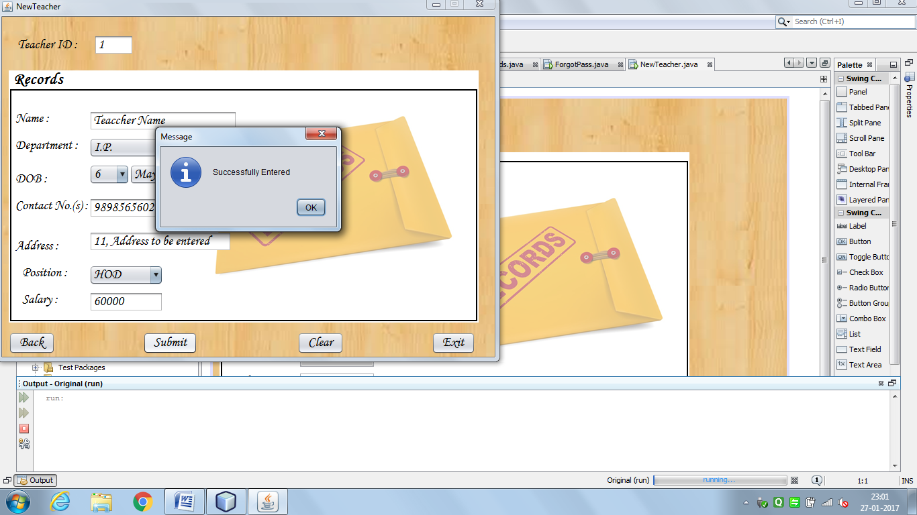

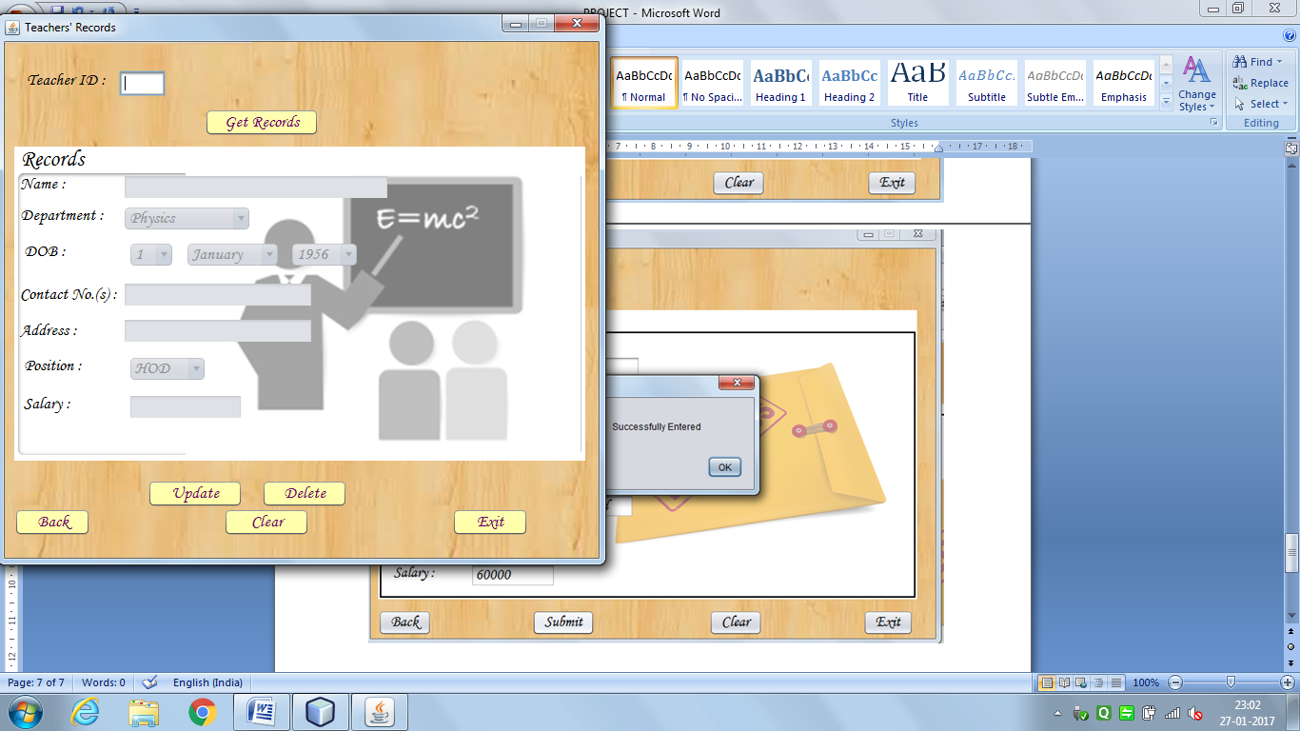

import java.sql.*;

import javax.swing.JOptionPane;

public TeacherRecords() {

initComponents();

Name.setEnabled(false);

Dept.setEnabled(false);

ddob.setEnabled(false);

mdob.setEnabled(false);

ydob.setEnabled(false);

Cno.setEnabled(false);

Add.setEnabled(false);

Post.setEnabled(false);

Sal.setEnabled(false);

}

Get Records Button:

String tid,nm,dept,cno,add,post,sal,dd,mm,yy,month;

Date dob;

tid = Tid.getText();

if(tid.isEmpty())

{

JOptionPane.showMessageDialog(this,"Please enter the Teacher ID","Error",JOptionPane.ERROR_MESSAGE);

}

else

{

try{

Class.forName("com.mysql.jdbc.Driver");

Connection con = DriverManager.getConnection("jdbc:mysql://localhost:3306/schooladmin",

"root",

"mysql");

Statement stmt = con.createStatement();

String query = "Select * from Teacher1 where Tid = '" +tid+ "'";

ResultSet rs = stmt.executeQuery(query);

Tid.setEnabled(false);

if(rs.next())

{

nm = rs.getString("Name");

dept = rs.getString("Dept");

dob = rs.getDate("DOB");

cno = rs.getString("Cno");

add = rs.getString("Address");

post = rs.getString("Position");

sal = rs.getString("Salary");

Name.setText(nm);

Cno.setText(cno);

Add.setText(add);

Sal.setText(sal);

Dept.setSelectedItem(dept);

ddob.setSelectedIndex(dob.getDate()-1);

mdob.setSelectedIndex(dob.getMonth());

ydob.setSelectedIndex(dob.getYear()-56);

Post.setSelectedItem(post);

Name.setEnabled(true);

Tid.setEnabled(false);

Dept.setEnabled(true);

ddob.setEnabled(true);

mdob.setEnabled(true);

ydob.setEnabled(true);

Cno.setEnabled(true);

Add.setEnabled(true);

Post.setEnabled(true);

Sal.setEnabled(true);

}else

{

JOptionPane.showMessageDialog(this, "ID not found","ERROR",JOptionPane.ERROR_MESSAGE);

Tid.setText("");

Tid.setEnabled(true);

}

}catch(ClassNotFoundException | SQLException e){JOptionPane.showMessageDialog(this, e,"ERROR",JOptionPane.ERROR_MESSAGE);}

}

Delete Button:

String tid = Tid.getText();

if(tid.isEmpty())

{

JOptionPane.showMessageDialog(this,"Please enter the Teacher ID","Error",JOptionPane.ERROR_MESSAGE);

}

else

{

try{

Class.forName("com.mysql.jdbc.Driver");

Connection con = DriverManager.getConnection("jdbc:mysql://localhost:3306/schooladmin",

"root",

"mysql");

Statement stmt = con.createStatement();

String check = "Select * from Teacher1";

String query = "Delete from Teacher1 where Tid ='" +tid+"'";

ResultSet rs = stmt.executeQuery(check);

if(rs.next())

{

int confirm = JOptionPane.showConfirmDialog(this,"Are you sure you want to Delete this Record","Confirm",JOptionPane.YES_NO_OPTION,JOptionPane.QUESTION_MESSAGE);

if(confirm==JOptionPane.YES_OPTION)

{

stmt.executeUpdate(query);

JOptionPane.showMessageDialog(this, "Successfully Deleted","Delete",JOptionPane.PLAIN_MESSAGE);

Tid.setText("");

Name.setText("");

Cno.setText("");

Add.setText("");

Sal.setText("");

Dept.setSelectedIndex(0);

ddob.setSelectedIndex(0);

mdob.setSelectedIndex(0);

ydob.setSelectedIndex(0);

Post.setSelectedIndex(0);

Tid.setEnabled(true);

Name.setEnabled(false);

Dept.setEnabled(false);

ddob.setEnabled(false);

mdob.setEnabled(false);

ydob.setEnabled(false);

Cno.setEnabled(false);

Add.setEnabled(false);

Post.setEnabled(false);

Sal.setEnabled(false);

}

}

else

{

JOptionPane.showMessageDialog(this,"Teacher ID not found","ERROR",JOptionPane.ERROR_MESSAGE);

}

}catch(ClassNotFoundException | SQLException e)

{JOptionPane.showMessageDialog(this,e,"ERROR",JOptionPane.ERROR_MESSAGE);}

}

Clear Button:

Tid.setText("");

Name.setText("");

Cno.setText("");

Add.setText("");

Sal.setText("");

Dept.setSelectedIndex(0);

ddob.setSelectedIndex(0);

mdob.setSelectedIndex(0);

ydob.setSelectedIndex(0);

Post.setSelectedIndex(0);

Tid.setEnabled(true);

Name.setEnabled(false);

Dept.setEnabled(false);

ddob.setEnabled(false);

mdob.setEnabled(false);

ydob.setEnabled(false);

Cno.setEnabled(false);

Add.setEnabled(false);

Post.setEnabled(false);

Sal.setEnabled(false);

Back Button:

new TeacherHome().setVisible(true);

this.dispose();

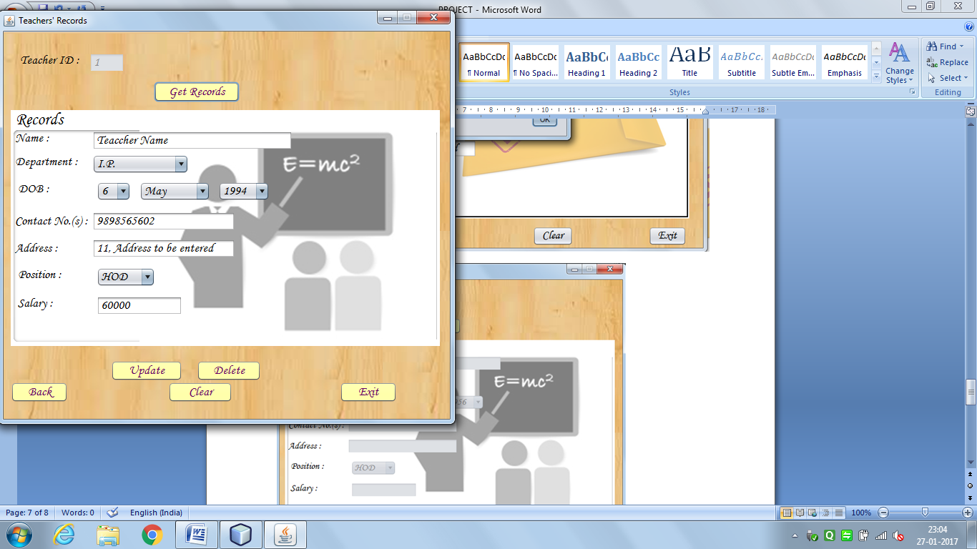

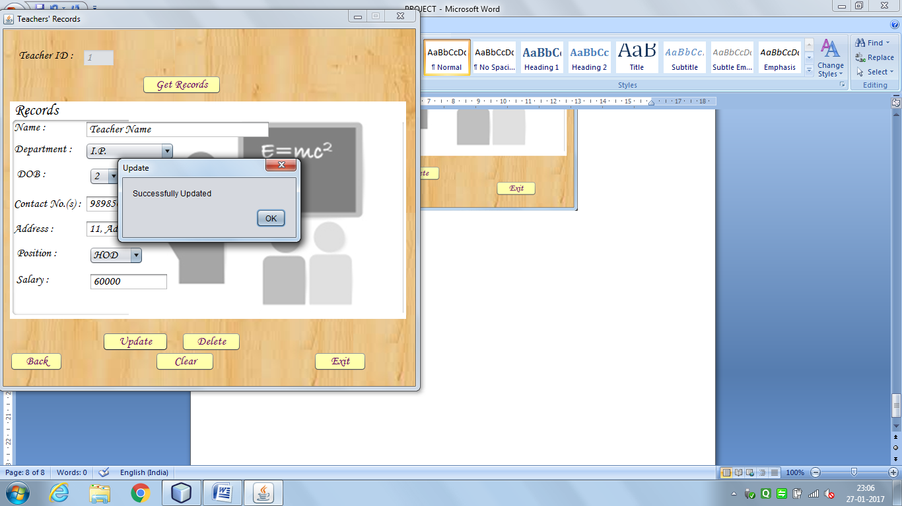

Update Button:

String tid,nm,dept,deptno,cno,add,post,sal,dd,mm,yy,month,dob;

tid = Tid.getText();

if(tid.isEmpty())

{

JOptionPane.showMessageDialog(this,"Please enter the Teacher ID","Error",JOptionPane.ERROR_MESSAGE);

}

else

{

nm = Name.getText();

dept = (String) Dept.getSelectedItem();

cno = Cno.getText();

add= Add.getText();

post = (String) Post.getSelectedItem();

sal = Sal.getText();

dd = (String)ddob.getSelectedItem();

month = (String)mdob.getSelectedItem();

mm = "01";

switch (month)

{

case "January" : mm = "01";

break;

case "February" : mm = "02";

break;

case "March" : mm = "03";

break;

case "April" : mm = "04";

break;

case "May" : mm = "05";

break;

case "June" : mm = "06";

break;

case "July" : mm = "07";

break;

case "August" : mm = "08";

break;

case "September": mm = "09";

break;

case "October" : mm = "10";

break;

case "November" : mm = "11";

break;

case "December" : mm = "12";

break;

}

yy = (String)ydob.getSelectedItem();

dob = yy+"/"+mm+"/"+dd;

if(nm.isEmpty()||cno.isEmpty()||add.isEmpty()||sal.isEmpty())

{

JOptionPane.showMessageDialog(this,"Please fill all the Entries","Error",JOptionPane.ERROR_MESSAGE);

}

else

{

try{

Class.forName("com.mysql.jdbc.Driver");

Connection con = DriverManager.getConnection("jdbc:mysql://localhost:3306/schooladmin",

"root",

"mysql");

Statement stmt = con.createStatement();

String query = "Update Teacher1 set Name = '" +nm+ "',Dept ='" +dept+ "',DOB ='" +dob+"',Cno ='" +cno+"', Address ='" +add+ "',Position ='" +post+ "',Salary ='" +sal+"' where Tid ='" +tid+ "'";

stmt.executeUpdate(query);

JOptionPane.showMessageDialog(this, "Successfully Updated","Update",JOptionPane.PLAIN_MESSAGE);

}catch(ClassNotFoundException | SQLException e){JOptionPane.showMessageDialog(this,e,"ERROR",JOptionPane.ERROR_MESSAGE);}

}

}

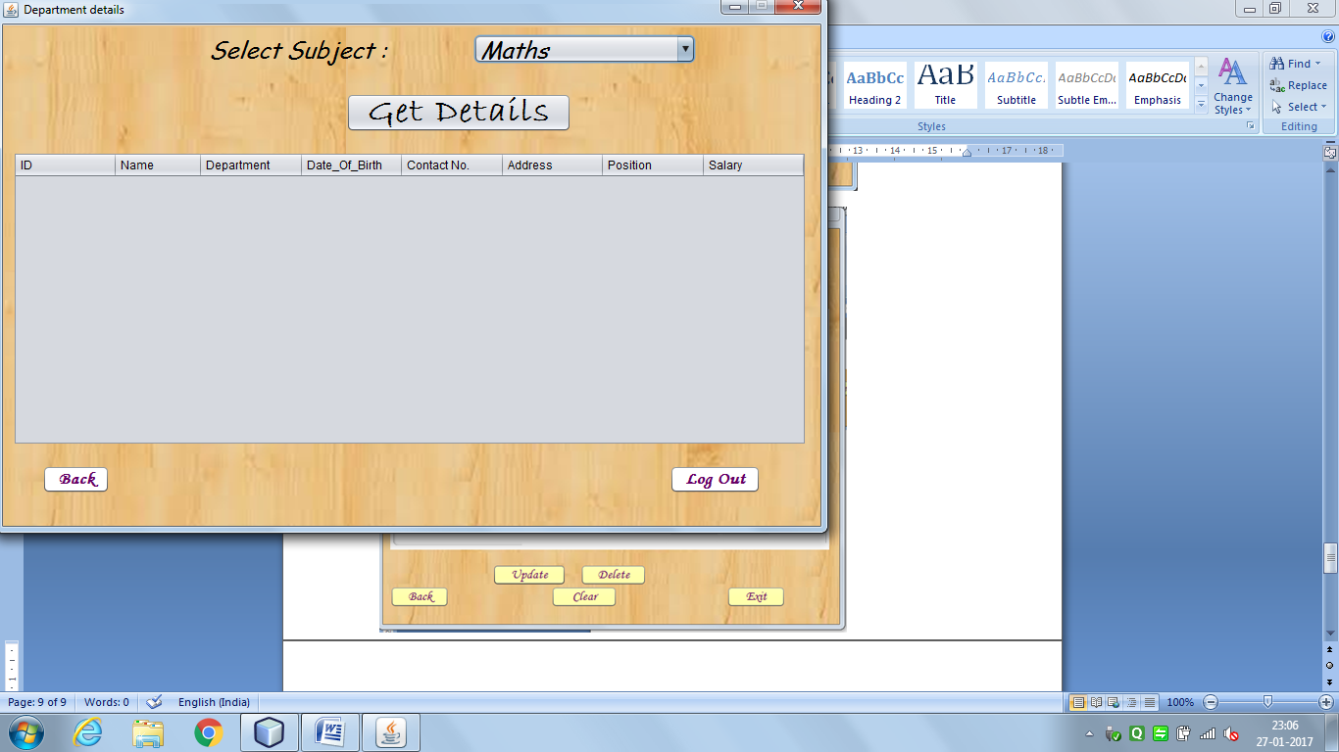

import java.sql.*;

import javax.swing.JOptionPane;

import javax.swing.table.DefaultTableModel;

Get Details Button:

DefaultTableModel dm = (DefaultTableModel)jTable1.getModel();

String subject= (String)jComboBox1.getSelectedItem();

try

{

int count = dm.getRowCount();

for(int i=0;i<count;i++)

{

dm.removeRow(0);

}

Class.forName("com.mysql.jdbc.Driver");

Connection con = DriverManager.getConnection("jdbc:mysql://localhost:3306/schooladmin","root","mysql");

Statement stmt = con.createStatement();

String sql = "select * from teacher1 where Dept='"+subject+"'";

ResultSet rs = stmt.executeQuery(sql);

while(rs.next())

{

String Tid = rs.getString(1);

String name = rs.getString(2);

String dept = rs.getString(3);

String dob = rs.getString(4);

String cno = rs.getString(5);

String address = rs.getString(6);

String pno = rs.getString(7);

String salary = rs.getString(8);

dm.addRow(new Object[]{Tid,name,dept,dob,cno,address,pno,salary});

}

}catch(Exception e)

{

JOptionPane.showMessageDialog(this,"Something went wrong, Please try again later");

}

Back Button:

new TeacherHome().setVisible(true);

this.dispose();

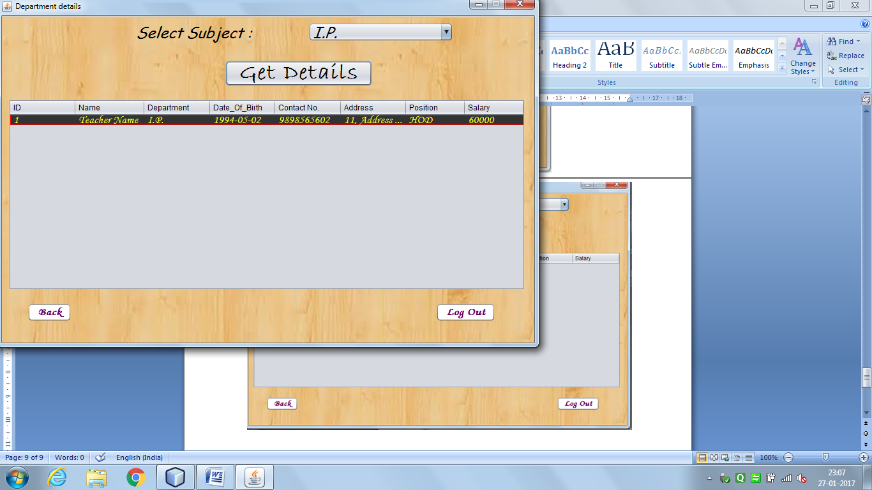

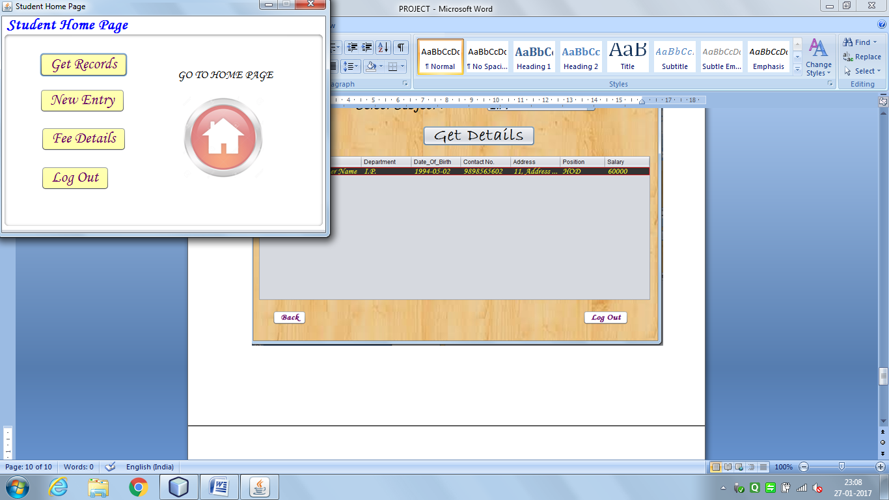

Get Records Button:

new StudentRecords().setVisible(true);

this.dispose();

New Entry Button:

new NewStudent().setVisible(true);

this.dispose();

Fee Details Button:

new Installments().setVisible(true);

this.dispose();

Back To Home Page Button:

new AdminHomePage().setVisible(true);

this.dispose();

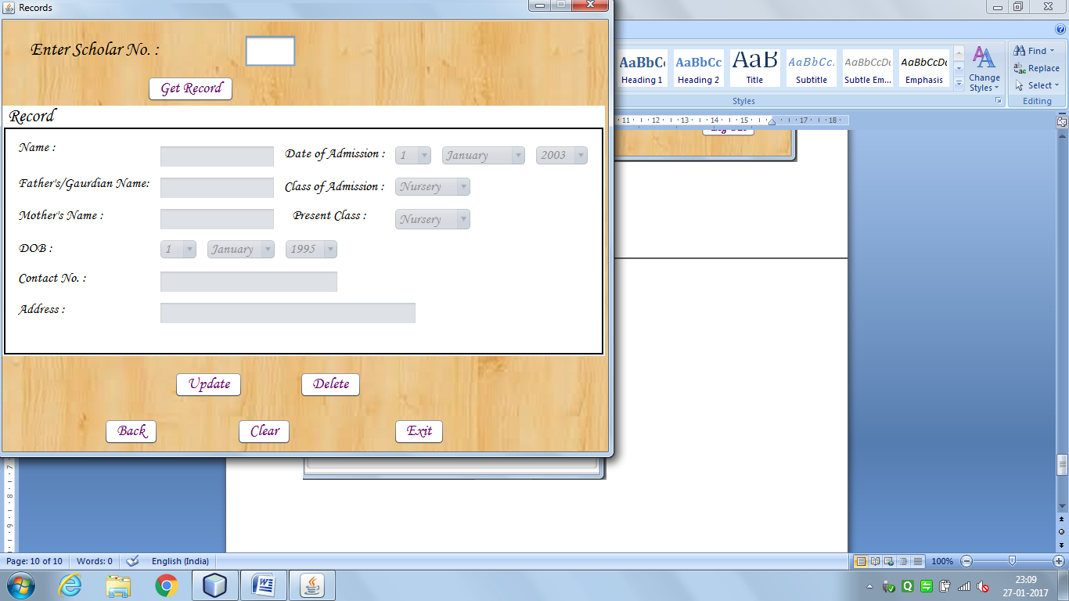

import java.sql.*;

import javax.swing.*;

import java.util.Date;

public StudentRecords() {

initComponents();

name.setEnabled(false);

fname.setEnabled(false);

mname.setEnabled(false);

ddob.setEnabled(false);

mdob.setEnabled(false);

ydob.setEnabled(false);

Cno.setEnabled(false);

Add.setEnabled(false);

ddoa.setEnabled(false);

mdoa.setEnabled(false);

ydoa.setEnabled(false);

cAdm.setEnabled(false);

pc.setEnabled(false);

}

Get Records Button:

String sno = schno.getText();

Date d = new Date();

if(sno.isEmpty())

{

JOptionPane.showMessageDialog(this,"Please enter the Scholar Number","Error",JOptionPane.ERROR_MESSAGE);

}

else

{

try{

Class.forName("com.mysql.jdbc.Driver");

Connection con = DriverManager.getConnection("jdbc:mysql://localhost:3306/schooladmin",

"root",

"mysql");

Statement stmt = con.createStatement();

String query = "Select * from NewEntry where SchNo ="+sno;

ResultSet rs = stmt.executeQuery(query);

schno.setEnabled(false);

int classno = 0;

if (rs.next())

{

String nm = rs.getString("Name");

String fnm = rs.getString("FatherName");

String mnm = rs.getString("MotherName");

Date dob = rs.getDate("DOB");

String cno = rs.getString("Cno");

String add = rs.getString("Address");

Date doa = rs.getDate("DOA");

String coa = rs.getString("COA");

switch(coa)

{

case "Nursery" : classno = -3;

break;

case "LKG" : classno = -2;

break;

case "UKG" : classno = -1;

break;

case "I" : classno = 1;

break;

case "II" : classno = 2;

break;

case "III" : classno = 3;

break;

case "IV" : classno = 4;

break;

case "V" : classno = 5;

break;

case "VI" : classno = 6;

break;

case "VII" : classno = 7;

break;

case "VIII" : classno = 8;

break;

case "IX" : classno = 9;

break;

case "X" : classno = 10;

break;

case "XI" : classno = 11;

break;

case "XII" : classno = 12;

break;

}

String pclass = "";

int pclassno;

if (d.getMonth()<4)

pclassno = d.getYear()-doa.getYear()+classno-1;

else

pclassno = d.getYear()-doa.getYear()+classno;

switch(pclassno)

{

case -3 : pclass = "Nursery";

break;

case -2 : pclass = "LKG";

break;

case -1 : pclass = "UKG";

break;

case 1 : pclass = "I";

break;

case 2 : pclass = "II";

break;

case 3 : pclass = "III";

break;

case 4 : pclass = "IV";

break;

case 5 : pclass = "V";

break;

case 6 : pclass = "VI";

break;

case 7 : pclass = "VII";

break;

case 8 : pclass = "VIII";

break;

case 9 : pclass = "IX";

break;

case 10 : pclass = "X";

break;

case 11 : pclass = "XI";

break;

case 12 : pclass = "XII";

break;

}

name.setText(nm);

fname.setText(fnm);

mname.setText(mnm);

ddob.setSelectedIndex(dob.getDate()-1);

mdob.setSelectedIndex(dob.getMonth());

ydob.setSelectedIndex(dob.getYear()-95);

Cno.setText(cno);

Add.setText(add);

ddoa.setSelectedIndex(doa.getDate()-1);

mdoa.setSelectedIndex(doa.getMonth());

ydoa.setSelectedIndex(doa.getYear()-103);

cAdm.setSelectedItem(coa);

pc.setSelectedItem(pclass);

name.setEnabled(true);

fname.setEnabled(true);

mname.setEnabled(true);

ddob.setEnabled(true);

mdob.setEnabled(true);

ydob.setEnabled(true);

Cno.setEnabled(true);

Add.setEnabled(true);

ddoa.setEnabled(true);

mdoa.setEnabled(true);

ydoa.setEnabled(true);

cAdm.setEnabled(true);

pc.setEnabled(true);

}else

{

JOptionPane.showMessageDialog(this, "id not found","ERROR",JOptionPane.ERROR_MESSAGE);

schno.setEnabled(true);

}

}catch(ClassNotFoundException | SQLException e){JOptionPane.showMessageDialog(this,e,"ERROR",JOptionPane.ERROR_MESSAGE);}

}

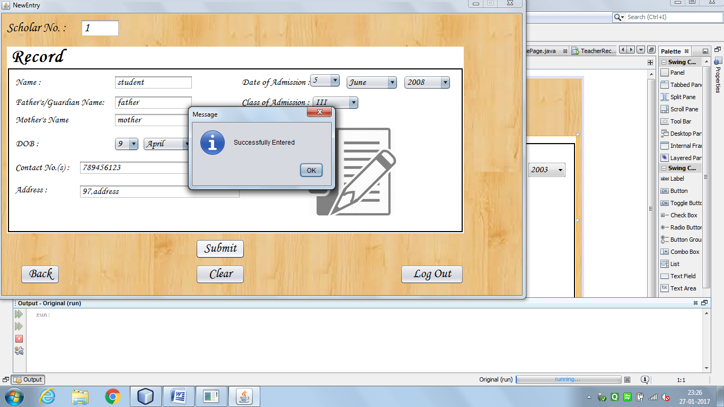

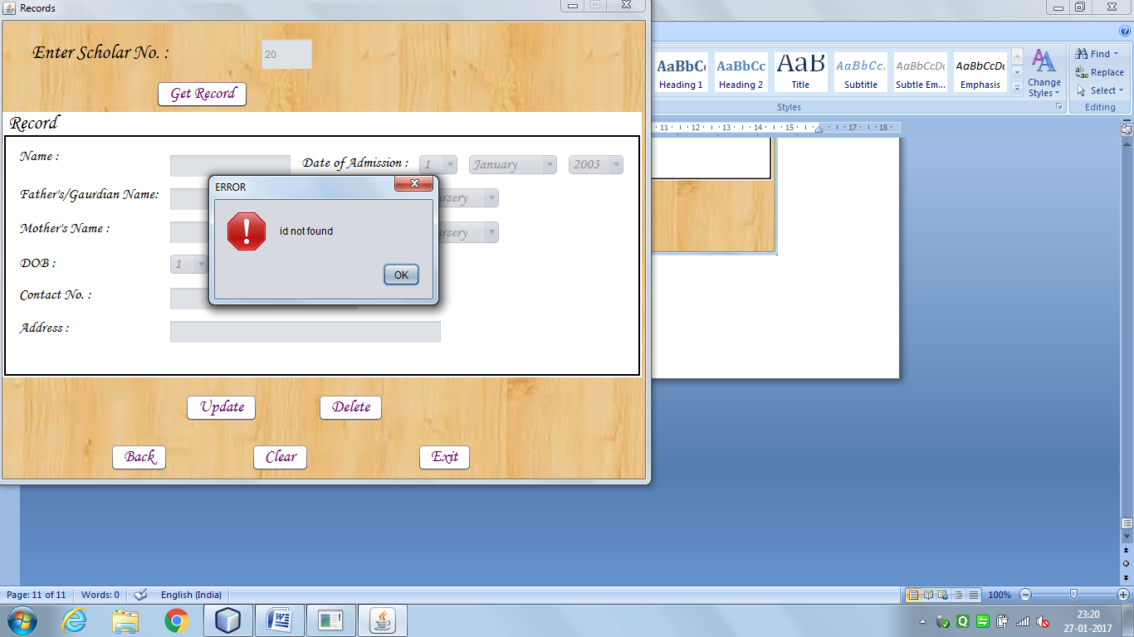

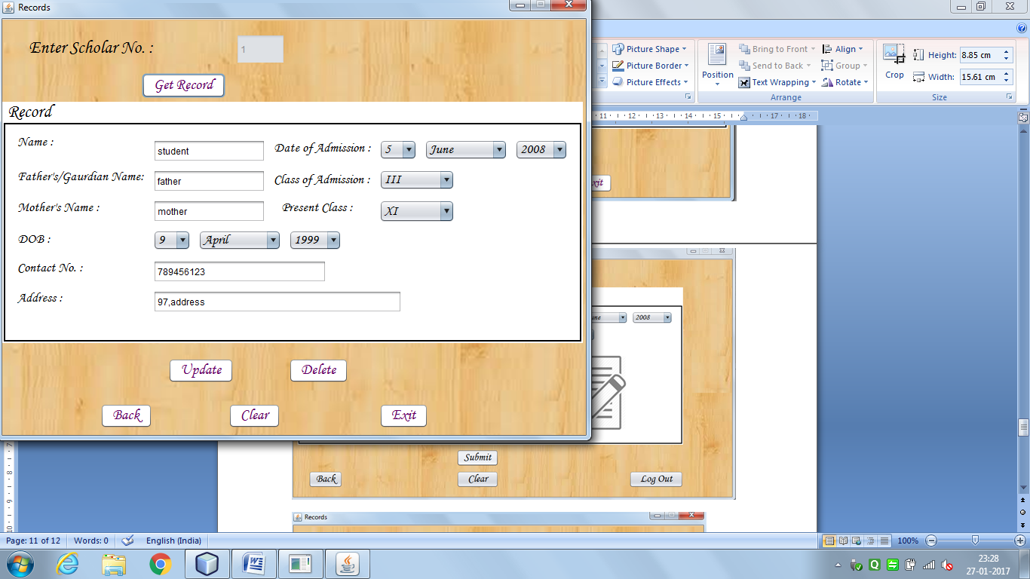

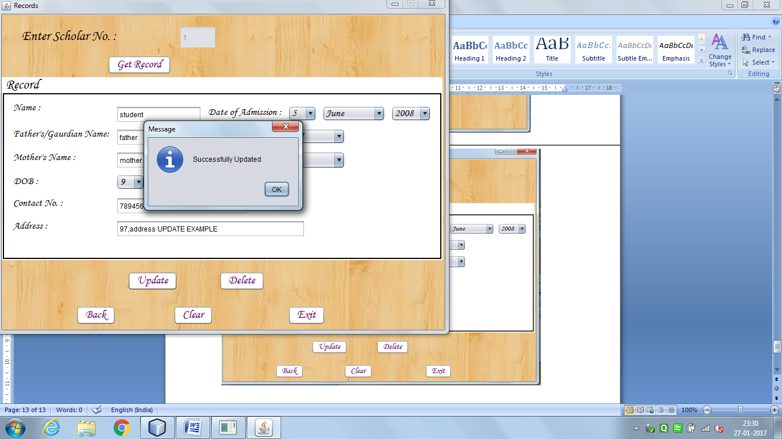

Update Button:

String sno = schno.getText();

if(sno.isEmpty())

{

JOptionPane.showMessageDialog(this,"Please enter the Scholar Number","Error",JOptionPane.ERROR_MESSAGE);

}

else

{

String nm = name.getText();

String fnm = fname.getText();

String mnm = mname.getText();

String dobd = (String) ddob.getSelectedItem();

String dobm = (String) mdob.getSelectedItem();

String doby = (String) ydob.getSelectedItem();

int m = 1; // Should be changed

switch (dobm)

{

case "January" : m = 1;

break;

case "February" : m = 2;

break;

case "March" : m = 3;

break;

case "April" : m = 4;

break;

case "May" : m = 5;

break;

case "June" : m = 6;

break;

case "July" : m = 7;

break;

case "August" : m = 8;

break;

case "September": m = 9;

break;

case "October" : m = 10;

break;

case "November" : m = 11;

break;

case "December" : m = 12;

break;

}

String dob = doby +"/"+m+"/"+dobd;

System.out.println(m+"");

String cno = Cno.getText();

String add = Add.getText();

String doad = (String) ddoa.getSelectedItem();

String doam = (String) mdoa.getSelectedItem();

String doay = (String) ydoa.getSelectedItem();

int mm = 1;

switch(doam)

{

case "January" : mm = 1;

break;

case "February" : mm = 2;

break;

case "March" : mm = 3;

break;

case "April" : mm = 4;

break;

case "May" : mm = 5;

break;

case "June" : mm = 6;

break;

case "July" : mm = 7;

break;

case "August" : mm = 8;

break;

case "September": mm = 9;

break;

case "October" : mm = 10;

break;

case "November" : mm = 11;

break;

case "December" : mm = 12;

break;

}

String doa = doay +"/"+mm+"/"+doad;

String coa = (String) cAdm.getSelectedItem();

if(nm.isEmpty()||fnm.isEmpty()||mnm.isEmpty()||cno.isEmpty()||add.isEmpty())

{

JOptionPane.showMessageDialog(this,"Please fill all the Entries","Error",JOptionPane.ERROR_MESSAGE);

}

else

{

try{

Class.forName("com.mysql.jdbc.Driver");

Connection con = DriverManager.getConnection("jdbc:mysql://localhost:3306/schooladmin",

"root",

"mysql");

Statement stmt = con.createStatement();

String query = "Update NewEntry set Name = '" +nm+ "', FatherName = '" +fnm+ "', MotherName = '" +mnm+ "', DOB = '" +dob+ "', Cno = '" +cno+ "', Address = '" +add+ "', DOA = '" +doa+ "', COA = '" +coa+ "' where SchNo ="+sno;

stmt.executeUpdate(query);

JOptionPane.showMessageDialog(this, "Successfully Updated");

}catch(ClassNotFoundException | SQLException e){JOptionPane.showMessageDialog(this,e,"ERROR",JOptionPane.ERROR_MESSAGE);}

}

}

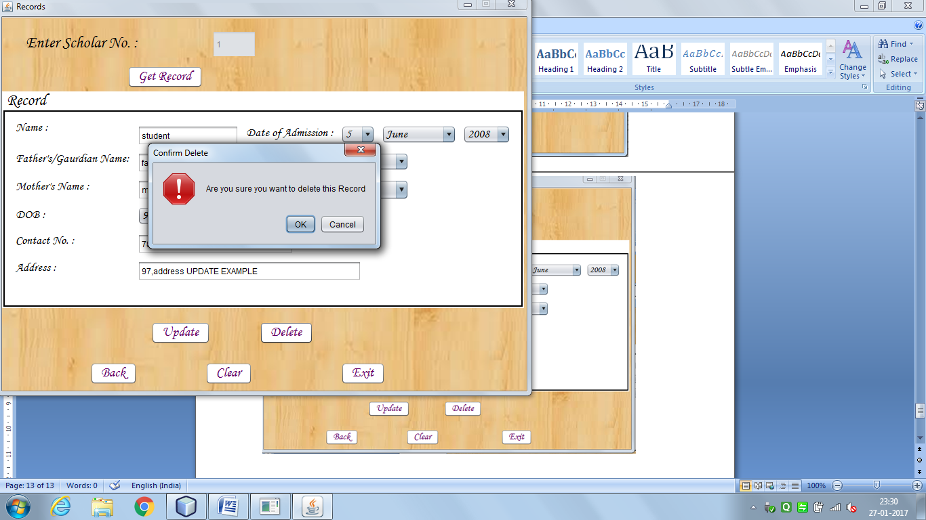

Delete Button:

String sno = schno.getText();

if(sno.isEmpty())

{

JOptionPane.showMessageDialog(this,"Please enter the Scholar Number","Error",JOptionPane.ERROR_MESSAGE);

}

else

{

try{

Class.forName("com.mysql.jdbc.Driver");

Connection con = DriverManager.getConnection("jdbc:mysql://localhost:3306/schooladmin",

"root",

"mysql");

Statement stmt = con.createStatement();

String check = "Select * from NewEntry";

String query = "Delete from NewEntry where SchNo =" +sno;

ResultSet rs = stmt.executeQuery(check);

if (rs.next())

{

int confirm = JOptionPane.showConfirmDialog(this,"Are you sure you want to delete this Record","Confirm Delete",JOptionPane.WARNING_MESSAGE,JOptionPane.YES_NO_OPTION);

if (confirm == JOptionPane.YES_OPTION)

{

stmt.executeUpdate(query);

JOptionPane.showMessageDialog(this, "Successfully Deleted");

schno.setText("");

name.setText("");

fname.setText("");

mname.setText("");

ddob.setSelectedIndex(0);

mdob.setSelectedIndex(0);

ydob.setSelectedIndex(0);

Cno.setText("");

Add.setText("");

ddoa.setSelectedIndex(0);

mdoa.setSelectedIndex(0);

ydoa.setSelectedIndex(0);

cAdm.setSelectedIndex(0);

schno.setEnabled(true);

name.setEnabled(false);

fname.setEnabled(false);

mname.setEnabled(false);

ddob.setEnabled(false);

mdob.setEnabled(false);

ydob.setEnabled(false);

Cno.setEnabled(false);

Add.setEnabled(false);

ddoa.setEnabled(false);

mdoa.setEnabled(false);

ydoa.setEnabled(false);

cAdm.setEnabled(false);

pc.setEnabled(false);

}

}

else

{

JOptionPane.showMessageDialog(this,"ID not found","ERROR",JOptionPane.ERROR_MESSAGE);

}

}catch(ClassNotFoundException | SQLException e){JOptionPane.showMessageDialog(this,e,"ERROR",JOptionPane.ERROR_MESSAGE);}

}

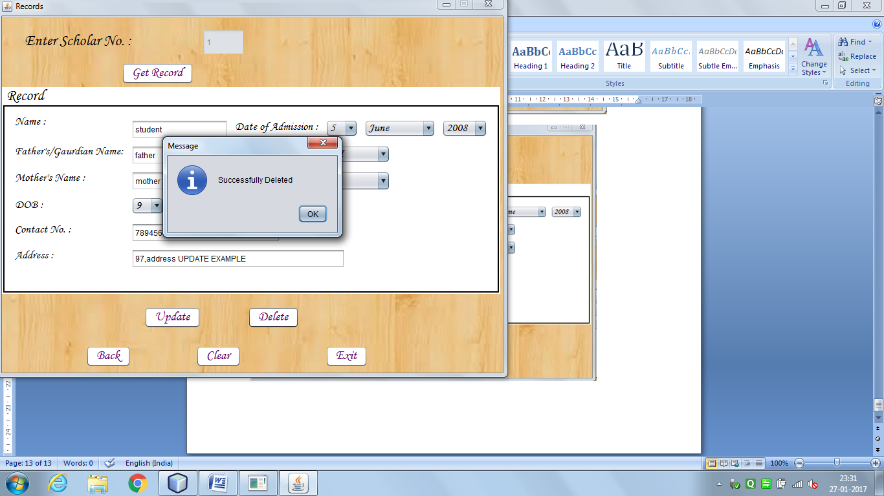

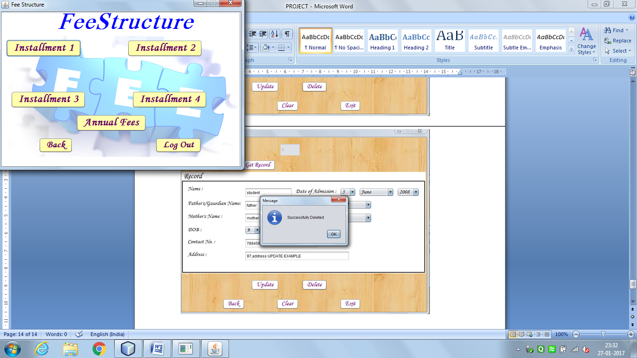

Installment1 Button:

new Fees1().setVisible(true);

this.dispose();

Installment2 Button:

new Fees2().setVisible(true);

this.dispose();

Installment3 Button:

new Fees3().setVisible(true);

this.dispose();

Installment4 Button:

new Fees4().setVisible(true);

this.dispose();

Annual Fees Button:

new annual().setVisible(true);

this.dispose();

Back Button:

new StudentHome().setVisible(true);

this.dispose();

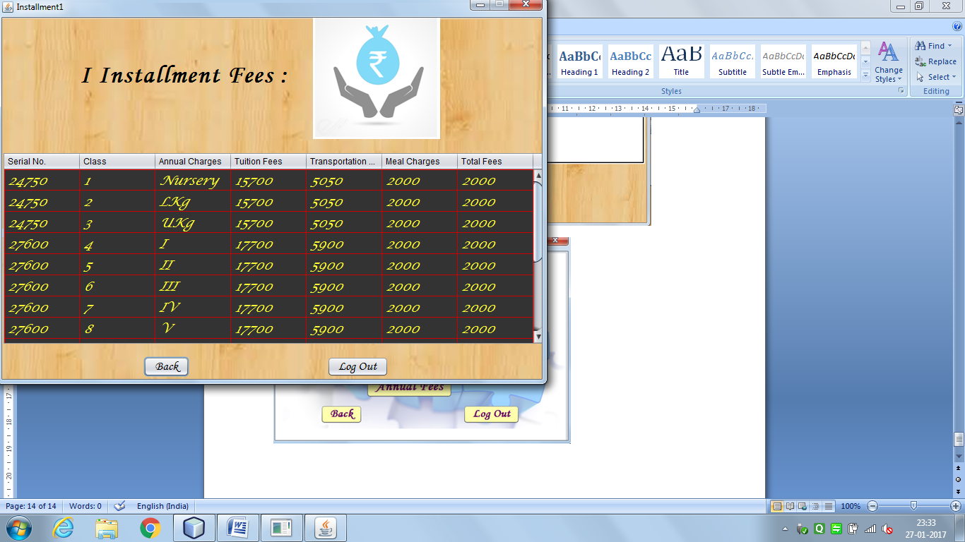

import java.sql.*;

import javax.swing.JOptionPane;

import javax.swing.table.DefaultTableModel;

public Fees1() {

initComponents();

DefaultTableModel dm = (DefaultTableModel)jTable1.getModel();

try

{

int count = dm.getRowCount();

for(int i=0;i<count;i++)

{

dm.removeRow(0);

}

Class.forName("com.mysql.jdbc.Driver");

Connection con = DriverManager.getConnection("jdbc:mysql://localhost:3306/schooladmin","root","mysql");

Statement stmt = con.createStatement();

String sql = "select * from FeeStructure order by sno";

ResultSet rs = stmt.executeQuery(sql);

while(rs.next())

{

String sno = rs.getString(7);

String cla = rs.getString(1);

String ann = rs.getString(2);

String Tuition = rs.getString(3);

String Trans = rs.getString(4);

String Meal = rs.getString(5);

String Total = rs.getString(6);

dm.addRow(new Object[]{cla,ann,Tuition,Trans,Meal,Total});

}

}catch(Exception e)

{

JOptionPane.showMessageDialog(this,"Something went wrong, Please try again later");

}

}

Back Button:

new Installments().setVisible(true);

this.dispose();

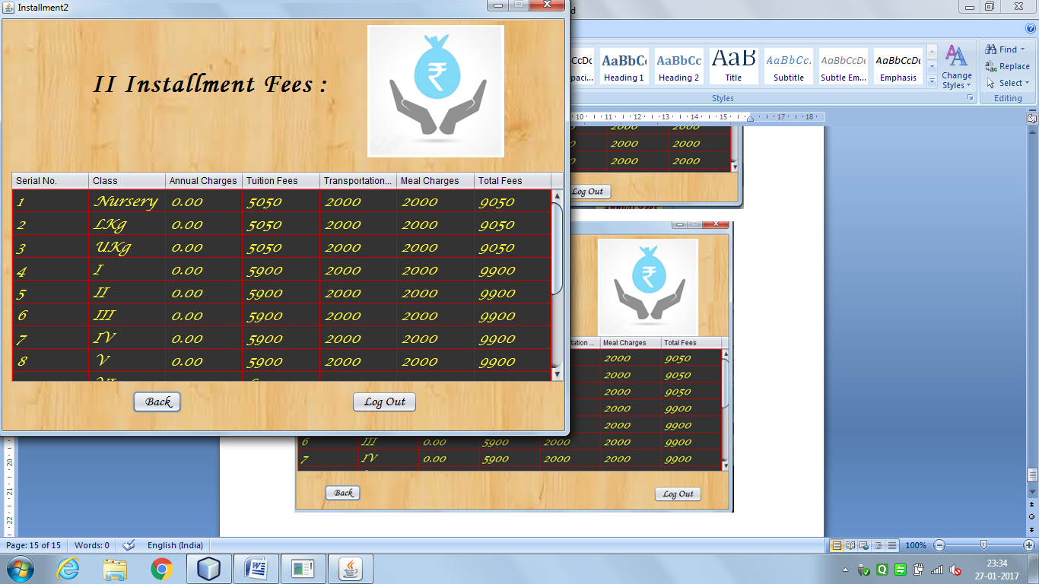

import java.sql.*;

import javax.swing.JOptionPane;

import javax.swing.table.DefaultTableModel;

public Fees2() {

initComponents();

DefaultTableModel dm = (DefaultTableModel)jTable1.getModel();

try

{

int count = dm.getRowCount();

for(int i=0;i<count;i++)

{

dm.removeRow(0);

}

Class.forName("com.mysql.jdbc.Driver");

Connection con = DriverManager.getConnection("jdbc:mysql://localhost:3306/schooladmin","root","mysql");

Statement stmt = con.createStatement();

String sql = "select * from installment order by sno";

ResultSet rs = stmt.executeQuery(sql);

while(rs.next())

{

String sno = rs.getString(7);

String cla = rs.getString(1);

String ann = rs.getString(2);

String Tuition = rs.getString(3);

String Trans = rs.getString(4);

String Meal = rs.getString(5);

String Total = rs.getString(6);

dm.addRow(new Object[]{cla,ann,Tuition,Trans,Meal,Total});

}

}catch(Exception e)

{

JOptionPane.showMessageDialog(this,"Something went wrong, Please try again later");

}

}

Back Button:

new Installments().setVisible(true);

this.dispose();

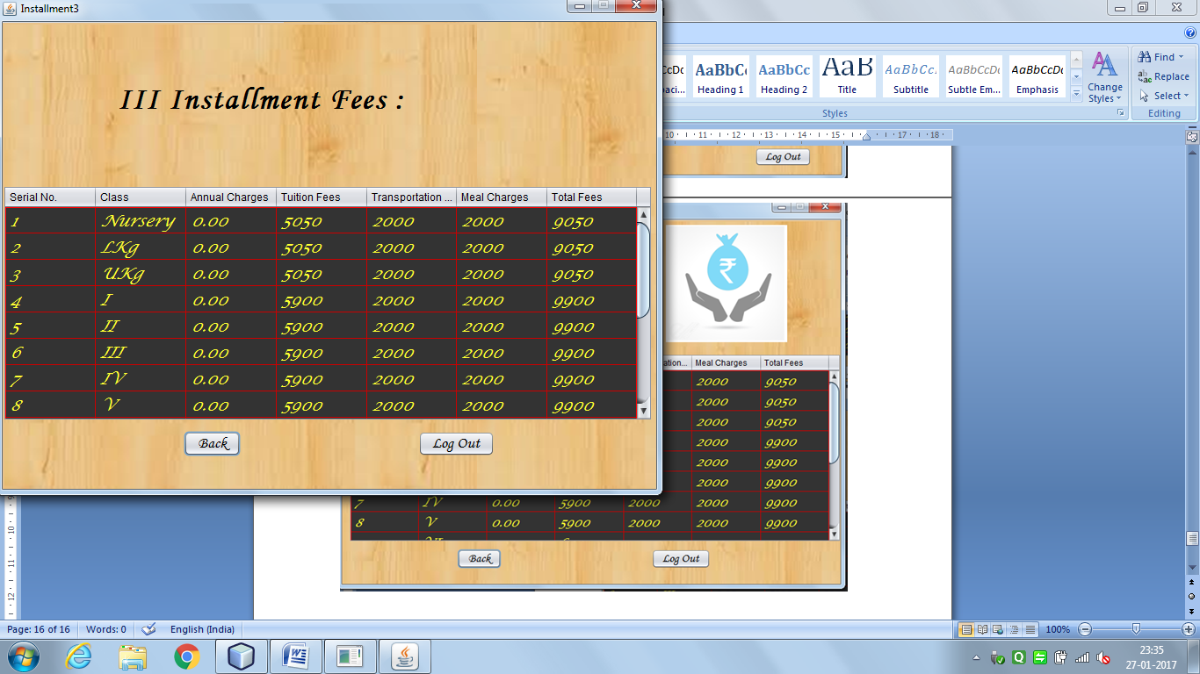 import java.sql.*;

import javax.swing.JOptionPane;

import javax.swing.table.DefaultTableModel;

public Fees3() {

initComponents();

DefaultTableModel dm = (DefaultTableModel)jTable1.getModel();

try

{

int count = dm.getRowCount();

for(int i=0;i<count;i++)

{

dm.removeRow(0);

}

Class.forName("com.mysql.jdbc.Driver");

Connection con = DriverManager.getConnection("jdbc:mysql://localhost:3306/schooladmin","root","mysql");

Statement stmt = con.createStatement();

String sql = "select * from installment order by sno";

ResultSet rs = stmt.executeQuery(sql);

while(rs.next())

{

String sno = rs.getString(7);

String cla = rs.getString(1);

String ann = rs.getString(2);

String Tuition = rs.getString(3);

String Trans = rs.getString(4);

String Meal = rs.getString(5);

String Total = rs.getString(6);

dm.addRow(new Object[]{cla,ann,Tuition,Trans,Meal,Total});

}

}catch(Exception e)

{

JOptionPane.showMessageDialog(this,"Something went wrong, Please try again later");

}

}

Back Button:

new Installments().setVisible(true);

this.dispose();

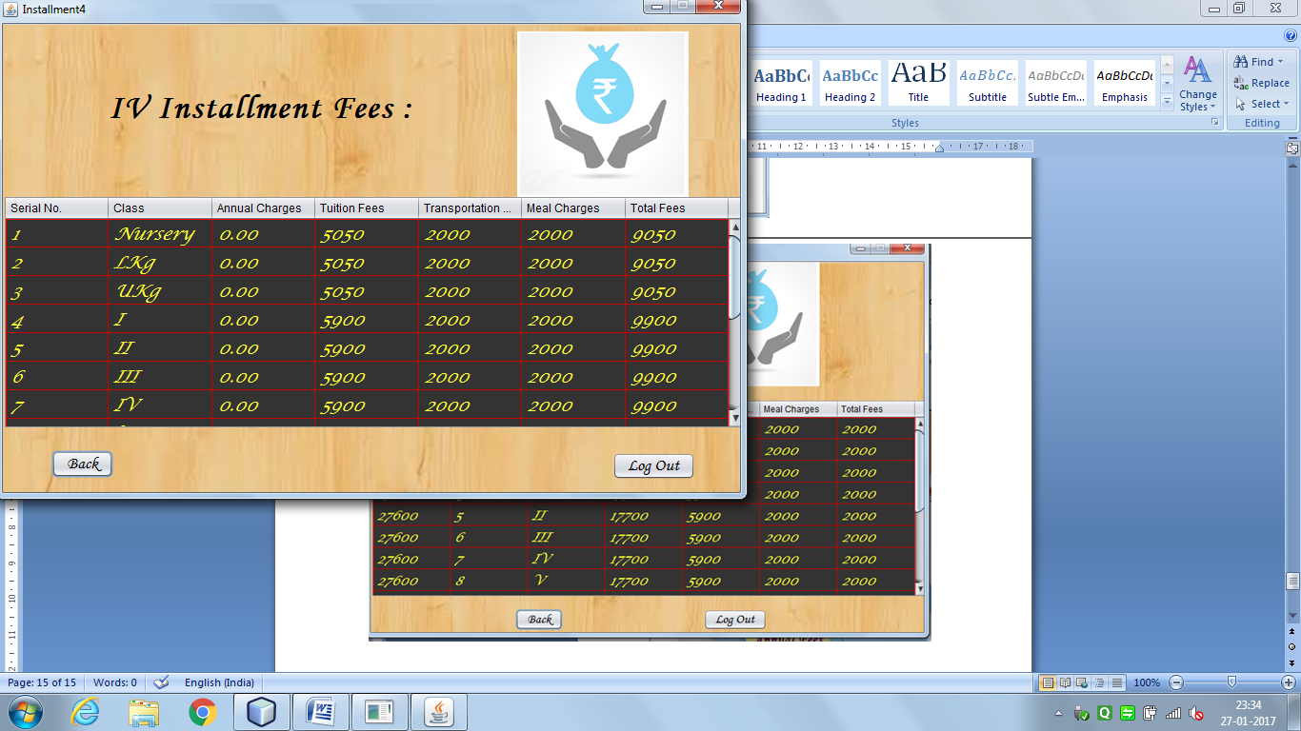

import java.sql.*;

import javax.swing.JOptionPane;

import javax.swing.table.DefaultTableModel;

public Fees4() {

initComponents();

DefaultTableModel dm = (DefaultTableModel)jTable1.getModel();

try

{

int count = dm.getRowCount();

for(int i=0;i<count;i++)

{

dm.removeRow(0);

}

Class.forName("com.mysql.jdbc.Driver");

Connection con = DriverManager.getConnection("jdbc:mysql://localhost:3306/schooladmin","root","mysql");

Statement stmt = con.createStatement();

String sql = "select * from installment order by sno";

ResultSet rs = stmt.executeQuery(sql);

while(rs.next())

{

String sno = rs.getString(7);

String cla = rs.getString(1);

String ann = rs.getString(2);

String Tuition = rs.getString(3);

String Trans = rs.getString(4);

String Meal = rs.getString(5);

String Total = rs.getString(6);

dm.addRow(new Object[]{cla,ann,Tuition,Trans,Meal,Total});

}

}catch(Exception e)

{

JOptionPane.showMessageDialog(this,"Something went wrong, Please try again later");

}

}

Back Button:

new Installments().setVisible(true);

this.dispose();

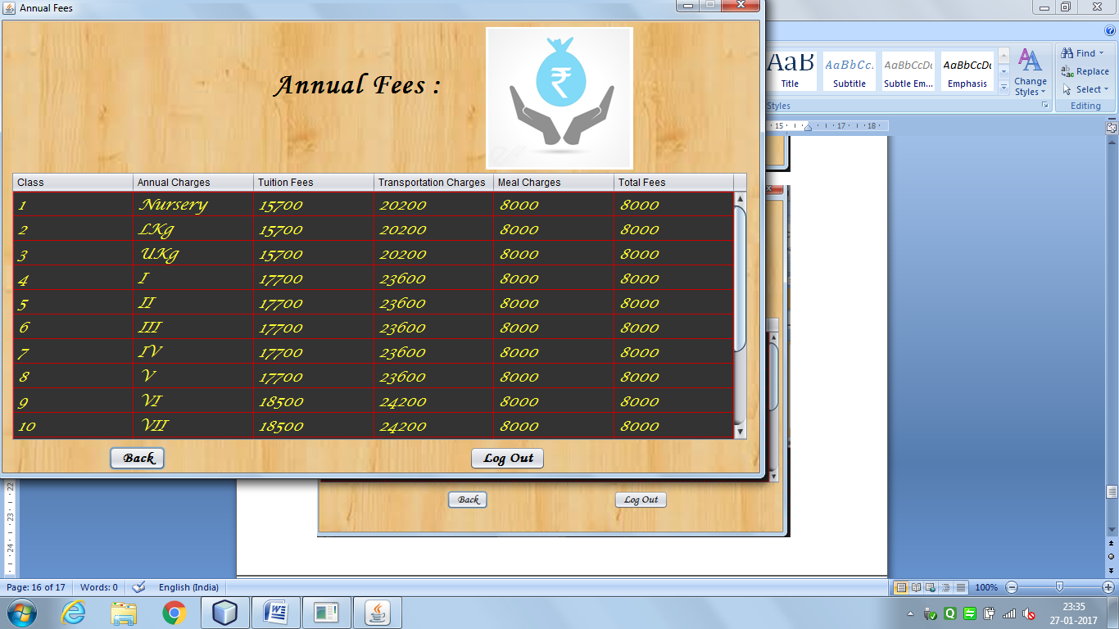

import java.sql.*;

import javax.swing.JOptionPane;

import javax.swing.table.DefaultTableModel;

public annual() {

initComponents();

DefaultTableModel dm = (DefaultTableModel)jTable1.getModel();

try

{

int count = dm.getRowCount();

for(int i=0;i<count;i++)

{

dm.removeRow(0);

}

Class.forName("com.mysql.jdbc.Driver");

Connection con = DriverManager.getConnection("jdbc:mysql://localhost:3306/schooladmin","root","mysql");

Statement stmt = con.createStatement();

String sql = "select * from annual order by sno";

ResultSet rs = stmt.executeQuery(sql);

while(rs.next())

{

String cla = rs.getString(1);

String ann = rs.getString(2);

String Tuition = rs.getString(3);

String Trans = rs.getString(4);

String Meal = rs.getString(5);

String Total = rs.getString(6);

dm.addRow(new Object[]{cla,ann,Tuition,Trans,Meal,Total});

}

}catch(Exception e)

{

JOptionPane.showMessageDialog(this,"Something went wrong, Please try again later");

}

}

Back Button:

new Installments().setVisible(true);

this.dispose();

**MYSQL**

